BURGER BOWL
Start With the bottom and work your way up!

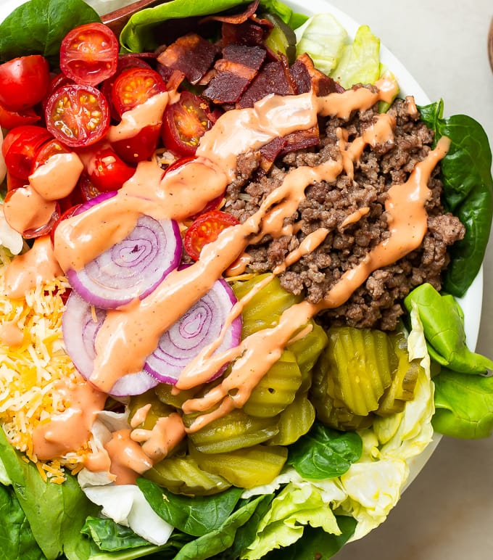

2c Romain Lettuce
4oz Ground Beef
½c grilled mushrooms
1 slice Munster cheese
Sliced Dill Pickles
2oz Avocado
*add and track condiments of choice

CAL- 324
Protein: 32
Carbs: 8
Fat: 24

